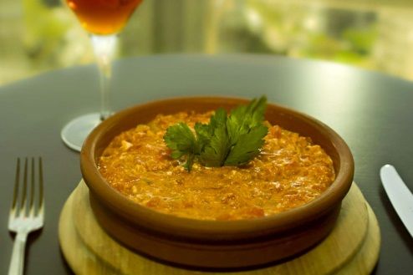
MENEMEN; Made of sautéed tomato, onion, green pepper and egg
Ingredients
Tomato 2 pieces, onion ½ piece, green pepper 1 piece, 20 gr butter, an egg, 2 gr peppercorns, 2 gram red flakes pepper and salt

Preparation;
Finely chopped onion and green pepper. The other side peeled tomato and chopped it as konkase. Sauteed onion in a pan with butter. After start to change color of onion add green pepper and two minutes later add konkase tomato. Keep it on small fire for ten minutes after add egg and mix it very slowly. Put salt, black pepper and red flakes pepper and take out from fire.

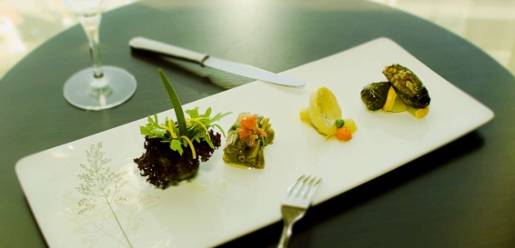
Seasonal vegetables cooked in olive oil
Stuffed wine leaves with rice & Fresh beans & Baby artichoke
Stuffed wine leaves;
Ingredients
50 gr Rice, 200 gr Onion, 50 ml Olive oil, 10 gr Pine nuts, 10
gr Currants, 5 gr Dried mint, ¼ bunch Fresh mint, 5 gr Cherry
Compote, 50 gr Lemon, Salt, 5 gr Pimento, 5 gr Cumin,
3 gr Powdered cinnamon, 2 Pickled leaves, ¼ bunch Fresh mint
Water (According to need)

Preparation;
First off, roast the pine nuts in 20ml of olive oil and then add the onions that have been thinly sliced. Once the onions are nicely cooked add in the washed and drained rice. Once all of it has been cooked add the spices and salt. Add enough water to cover the rice half way and then cover and over a low heat cook for 4-5 minutes. Finely chop the parsley and fresh mint and distribute evenly to all the mixtures. Wrap the leaves around the mixture. Place any sort of plate upside down on the roof of a casserole with a lid. Place half an onion, carrot and lemon slices on top. Cover this with the remaining leaves. Add a little salt and sugar and then place the remaining lemon slices on top. Drizzle 15 ml olive oil and enough water to cover the stuffed leaves and then place another plate on top so that they don’t fall apart. Finally cover the casserole with its own lid and over a low heat boil for 45 minutes. After they’re cooked let them cool inside the casserole so that they don’t darken.

Fresh Beans;
Ingredients
100 gr fresh bean, 50 gr Onion, 50 ml Olive oil, 50 gr tomato
Salt,sugar, a leave of spring onion and water (According to need)

Preparation;
Clean the fresh beans and cut it thoroughly. Bind the beans bunch with spring onion. Put it a saucepan.Add finely chopped onion and concase tomato on beans. Add salt, sugar, olive oil and little water. Cover it with oil paper. Keep it on small fire for ten minutes. After check it and take out on fire.

Artichoke;
Ingredients
1 piece artichoke,1/2 piece carrot,1/2 piece potato, 5 gram green peas, ½ piece orange, 10 mlt olive oil, salt, 1 piece bayleave.
Preparation;
Boiled artichoke in water for five minutes. Clean carrot and potato and take three pieces both of them with parizien spoon. Peel orange and squeze it. Put olive oil in a pan and add parizien vegetable, orange skin and bay leave. Sauteed all one for five minutes. After add orange juice and a little water.When start to boiling add artichoke inside. Keep it on small fire for ten minutes and after check to cooking add salt. Boiled green peas seperate. Take out artichoke on fire and add green peas.
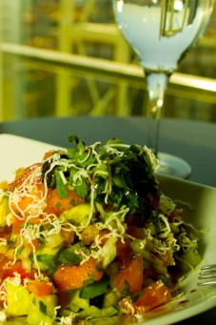
Shepherd salad; Tomato, cucumber, onion, green pepper, parsley, walnut, white cheese and sour pomegranate
Ingredients
A Tomato, a cucumber, ½ piece onion, a piece spring onion, a green pepper, ¼ bunch of parsley, 5 mlt sour pomegranate, feta cheese, 10 mlt olive oil and salt

Preparation;
Clean all vegetable and peel them. After cut all one like a cubes. Put in a bowl and add olive oil, sour pomegranate and salt. Take a service plate and grated feta cheese on salad.

Traditional red lentil soup served with crouton and lemon (4 pax)
Ingredients
200 gram red lentil, 30 gram butter, a piece carrot, a piece lemon, ½ piece onion, a piece potato, 2 lt water, 20 gram salt, 5 gram flakes red chili pepper.

Preparation;
Wash lentil for three times with cold water and filter it. Put lentil in a pan add water, finely choped onion, carrot and potato. Cut lemon and put it, too. When start to boiling keep on small fire for 45 minutes. Take out lemon and mix soup with thomson blendır. Strain soup and put on fire again. Add salt, red flakes pepper and butter and take out from fire.

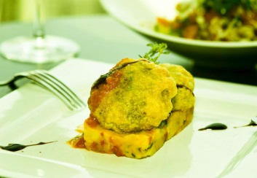
Kadınbudu köfte; Deep fried meatball served with potato pure with sun dried tomato and basil
Ingredients
250 g ground beef, 40 g rice (washed and drained), 1/2 piece onion (chopped), parsley (chopped), salt and pepper
For Frying
50 g floor, 1 piece egg (beaten), 1lt sunflower oil

Preparation
Boil rice in a cup of hot water and add salt. Leave it to cool. Cook ground beef in skillet till its color turns to brown over medium heat. Then stir in onion and the remaining salt. Cook till onions get soft over low heat (3-4min). Finally stir in the parsley and the spices and turn the heat off. In a large bowl mix the cooked ground meat mixture, rice and the remaining raw round beef. You can knead with your hands if you like. Cover the mixture adds leave in the fridge for about 30 minutes. Take egg size pieces and make egg shapes and flatten wish your hands. In a frying pan, sizzle oil. Place flour in a wide plate. In another plate beat the eggs. First dip the koftes in flour, make sure the koftes to be covered evenly with four. Then dip into egg and fry both sides until they get lightly golden brown.

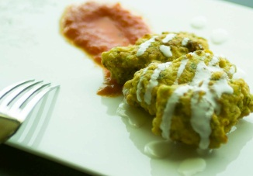
Mücver; Fried seasonal vegetable patty served with light tomato sauce
Ingredients
5-6 small firm zucchinis, grated or left over zucchini carvings from stuffed zucchinis (makes ~4 cups)
3 eggs
1/3 cup chopped flat leaf parsley
1/3 cup chopped fresh dill
2-3 tbsp or 1/4 cup chopped fresh mint (depending on how much you like mint)
3-4 green onions, finely chopped
1 cup white cheese/feta
1 tbsp paprika
salt
black pepper
~1 1/2 cup flour
1/2 cup olive oil for frying
Preparation
-Put grated zucchini in a colander. Sprinkle with salt and let drain for 10 minutes. Squeeze and place in a bowl.
-Mix well all the ingredients except for flour and frying oil.
-Add flour in slowly and mix well.
-Heat oil in a frying pan. On medium drop scoops of mücver mixture in hot oil. Make sure they don't touch.
-Fry them on each side until golden brown, 4-5 minutes.
-Drain excessive oil by placing fritters on paper towels.
-Serve with plain yogurt or garlicy yogurt sauce. For garlicy yogurt sauce beat every 1 cup of yogurt with 1 clove of minced garlic.

,
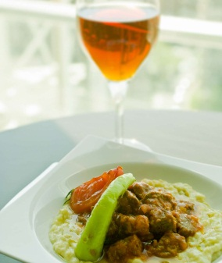
Favorite of Sultan; Cubes sautéed beef on eggplant pure
Ingredients
for the stew
1 lb stew lamb (preferably from leg)
1 onion, finely chopped
2 green chilies or bell pepper, finely chopped
2 tomatoes, petite diced
2 tbsp tomato paste
2-3 tbsp butter
salt and pepper
1/2 cup parsley, finely chopped
1-1 1/2 cup hot water
for the eggplant puree
2 lb eggplant
1/4 cup white flour
1/4 cup butter
1/2 cup grated Turkish hard mature cheese OR kashkaval cheese OR parmesan
1-1 1/2 milk
juice of 1 lemon
salt and pepper
Preparation
-Heat butters in a pot and sautéed the onions for a couple of minutes. Then add the meat. When browned on all sides, add green pepper. Stir for a couple of minutes.
-Add tomato paste and stir for another couple of minutes.
-Add tomatoes and cook for 5 minutes.
-At this point add the hot water and let simmer until meat is tender, approximately an hour. Add more water if need be.
-Meanwhile, wash and prick the eggplants with a fork on at least two sides.
-Place eggplants on gas burner or under broiler turning them frequently until eggplant is collapsed and skin is charred. You can also bake them until flesh is soft, but charred tastes better.
-Let cool and then peel eggplants and discard stems.
-Mash eggplant with the back of a fork in a bowl and mix with lemon juice.
-Heat butther in a pot. Add flour and stir constantly to make a roux on low heat.
-Warm the milk and add slowly. Whisk to make the mixture smooth. Simmer for 4-5 minutes.
-Add eggplant puree and mix well.
-Add salt and black pepper, and cheese. Mix well. Simmer for another 2-3 minutes.
-Make a bed on a plate with eggplant puree and place meat on top of eggplant puree. Sprinkle with chopped parsley.

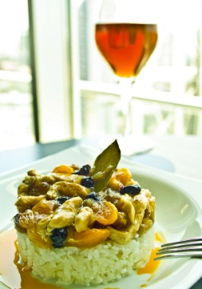
Mahmudiye; Sautéed sliced chicken dry fruits and nuts on rice
Ingredients
2 pieces chicken breast, skinless, boneless, cut in cubes
2+1 tbsp butter
16-18 pearl onions, peeled
6 dry apricots
1 bunch seedless grapes, small size or 3 tbsp Sultana or Golden raisins, stems cut off - soak into the hot water for 20 minutes and drain
1 tsp honey
2 tbsp lemon juice
1 cup hot water or chicken broth
1/2 tsp cinnamon
4 tbsp blanched almonds, sliced
Salt
Pepper
Preparation
Sauté the chicken with 2 tbsp butter for a few minutes in a medium sized pot. Add the pearl onions, sauté for about 2-3 more minutes while stirring occasionally. Add the apricot, half of the grapes or Sultana raisins, honey, lemon juice, hot chicken broth, salt and pepper. Put the lid on and cook for about 30 minutes on medium-low heat. Turn the heat off. Sprinkle the cinnamon all over the dish, stir.
Roast the almonds and the rest of the grape or Sultana raisins with 1 tbsp butter for about 2-3 minutes. Place the dish on a service plate; throw the almonds and grapes all over it.

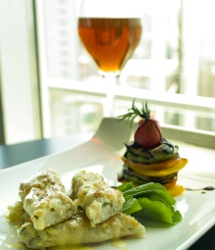
Seafood Kebab served with grilled vegetables and arugula leaves
Ingredients
Fillet of sea bass, 3 pieces prawn, a calamari, 10 gram fresh basil, 10 gram fresh ginger, a lemon grass a garlic, salt, black pepper, 10 gram coriander
Method; Clean all seafood and mashed them. Finely chopped other materials and add to seafood. Mix it in blender.
Semolina halva with ice cream and chocolate sauce
Ingredients
125 g butter, 250 g semolina, 25 g peanut, 200 ml water, 200 ml milk, 400 g sugar
Preparation

Melt the butter in a large and deep pot. Pour two cups semolina and peanuts in it and sauté it over low heat stirring continually with a wooden spoon. Low heat is so important here, otherwise semolina gets dark very easily but not cooked. So you must be patient to wait some time (about 20 or 30 minutes) to cook it fine. Do not forget to stir it continually if you don’t want an overcooked halvah. You will feel its hearty scent and see the change in its color. It will turn from yellow to brownish color gradually. This means it’s cooked. Meanwhile boil water and milk mixture in another pot. While the semolina is still on fire, pour the boiled water-milk mixture on it very carefully. Since both of them are very hot, when you pour the water, you’ll hear a very loud boiling noise “cossssss!” To prevent it from splashing on the cooker, cover its lid immediately. After a few minutes, add sugar and stir. Cook it for a few minutes more and take from fire

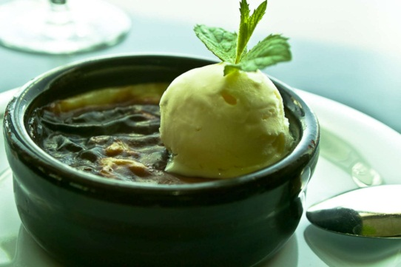
Baked rice pudding served with vanillin ice cream

Ingredients:
500 ml milk
100 g sugar
20 g starch
20 g rice

Preperation:
Boil the milk and add rice in it. Stir them and boil again. Cook the rice until they become very soft. Stir continuously. Have some cold water, add starch in it and dissolve the starch. Add in mixture. Stir. Add sugar and mixed them. Take it from the cooker after it boils.

Pour the blend into small bowls. Pour some water into the oven tray and put the bowls into the tray. Cook it in 250 grad oven for 35-40 minutes. After it’s cooked take it from the oven and put it into the refrigerator.

